Different ways to connect to an AWS Linux server (EC2 instance).

Here are the different ways to connect to an AWS Linux server (EC2 instance). I’ve explained each method clearly so you can use it in interviews, blogs, or documentation.

🔐 How to Connect to an AWS Linux Server (EC2) – Different Methods
Connecting to an AWS Linux EC2 instance can be done using multiple shells, protocols, and tools. Below are the most commonly used and reliable methods.

Connect Using SSH (Terminal / Shell) – Most Common
This is the standard way to connect.

Supported Shells
- Bash
- Zsh
- PowerShell (Windows)
- Git Bash (Windows)
- Windows Subsystem for Linux (WSL)
WSL, or the Windows Subsystem for Linux, is a Microsoft Windows feature that allows you to run a Linux environment, including command-line tools and applications, directly on Windows without a virtual machine or dual-boot setup. It is popular among developers for working with both Windows and Linux, and it supports installing various Linux distributions like Ubuntu and Debian.

Connect Using EC2 Instance Connect (Browser-Based SSH)
No need for a key file (for Amazon Linux 2 and Ubuntu).

Steps
- Go to: AWS Console → EC2 → Instances
- Select instance → Click Connect
- Choose EC2 Instance Connect
- Click Connect (opens browser shell)
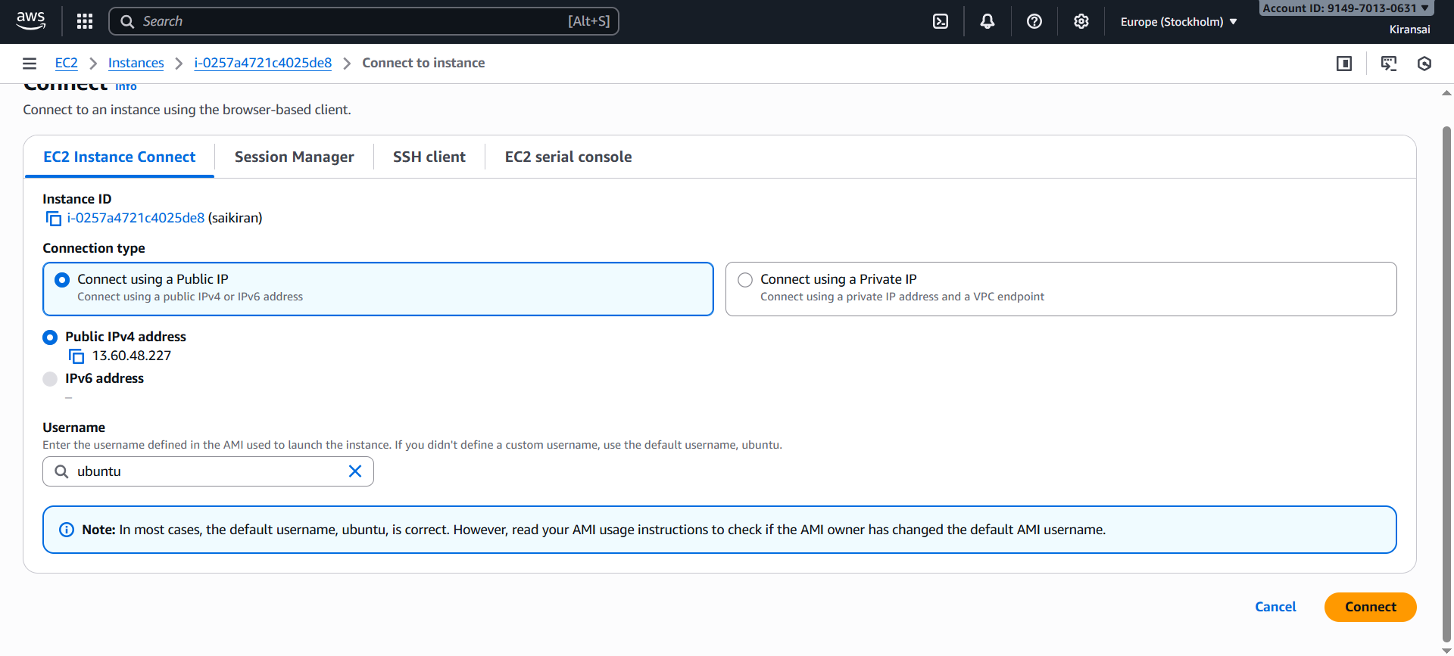
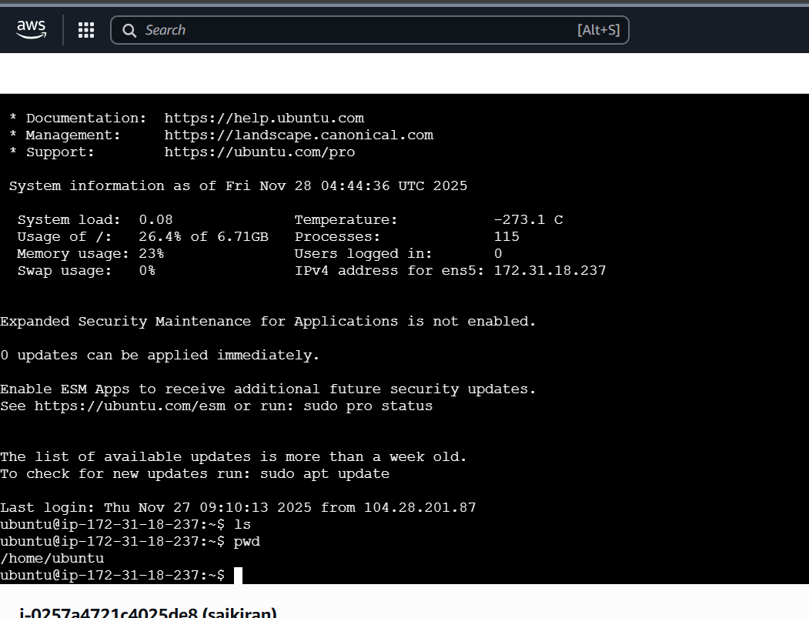

Connect Using Windows Subsystem for Linux (WSL)

To connect using WSL, open PowerShell as an administrator and use the wsl --install command to install it and the default Ubuntu distribution
- Restart your computer: A restart is required to complete the installation.

sudo apt update

sudo apt upgrade

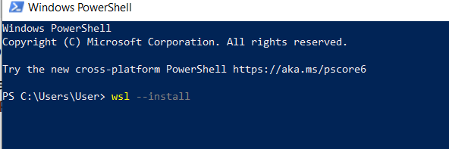
Connect Using PuTTY (Windows Users)

PuTTY is a free and open-source terminal emulator for Windows that allows users to connect to and manage remote systems. . It allows you to connect to remote computers or devices using various protocols such as secure socket shell (SSH), Telnet, login, and more. Putty is widely used by system administrators, network engineers, and developers for managing and controlling remote systems.
Useful when .pem needs to be converted.
Prerequisites:
PuTTY and PuTTYgen installed.
The private key file (.pem) associated with your EC2 instance.

Steps
- Convert .pem to .ppk using PuTTYgen
- Open PuTTY → Enter Public IP
- Auth → Select .ppk
- Connect
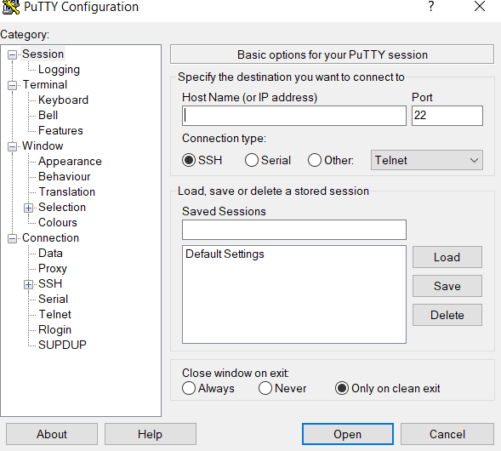
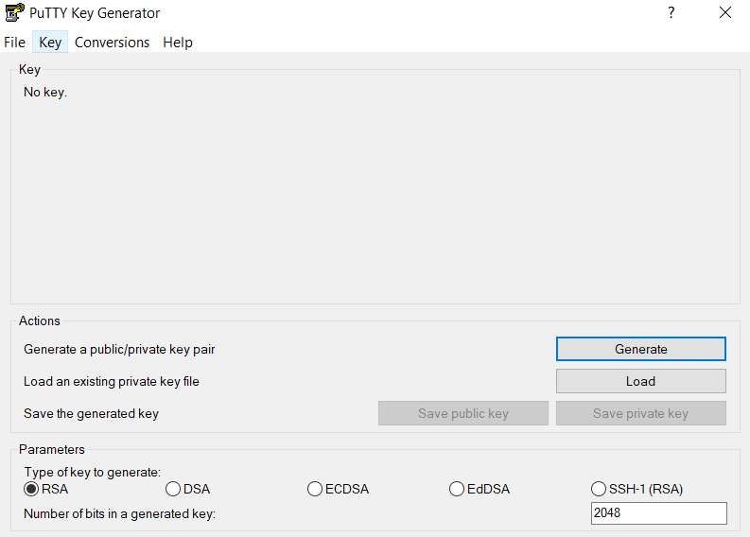

Connect Using MobaXterm

MobaXterm is a powerful SSH client for Windows with a built-in terminal. You can easily connect to any Linux server (AWS EC2, on-prem Linux, etc.) using it.

A fully configured X server is included, allowing users to easily display graphical applications from remote Unix/Linux systems on their Windows desktop.
More advanced SSH client for Windows.

Features
- Built-in SFTP
- SSH key management
- Tabbed terminal
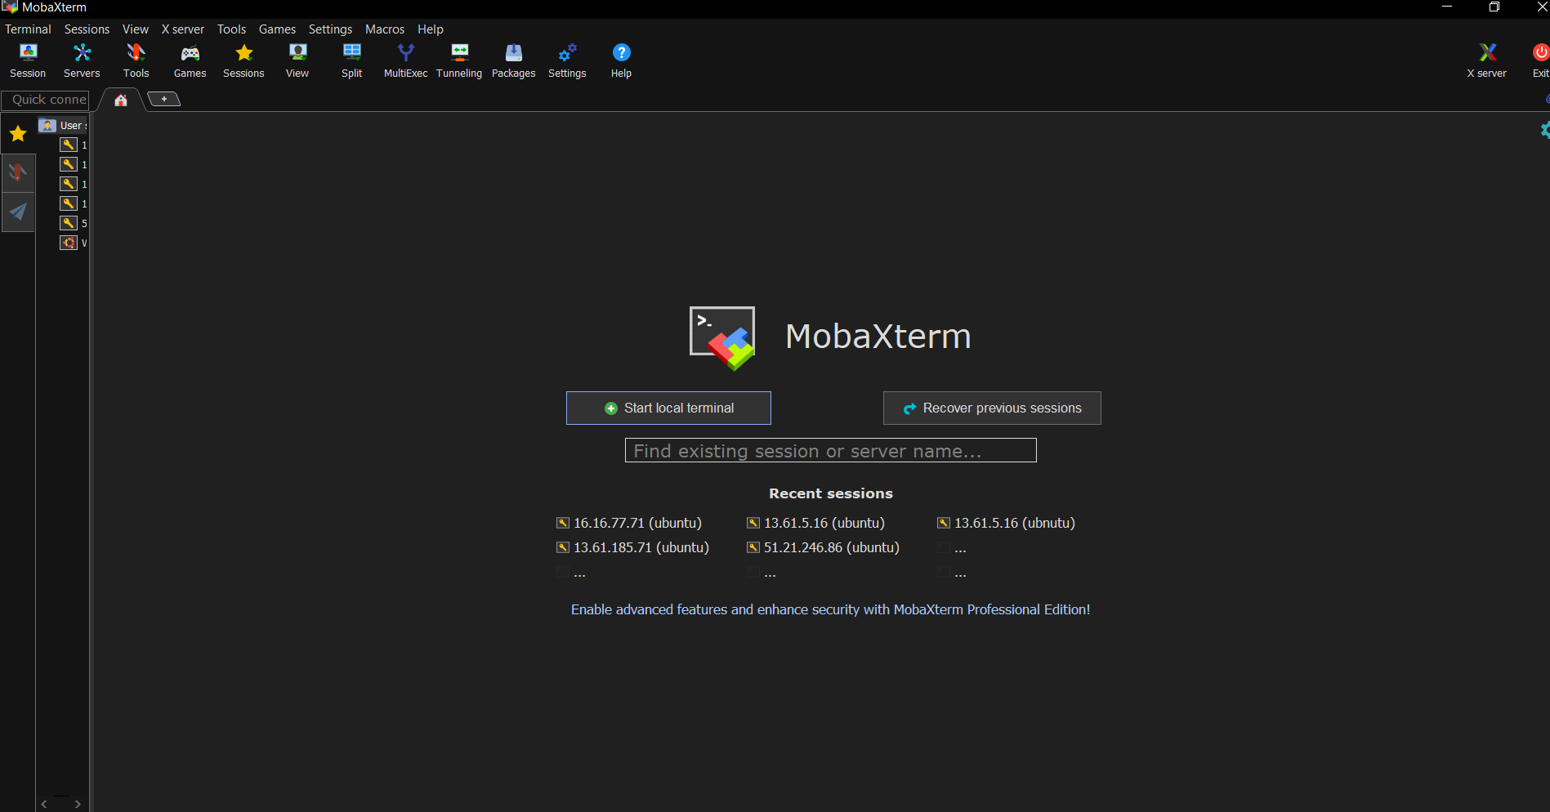

Connect Using AWS CloudShell
AWS CloudShell is a browser-based shell environment provided by AWS. It allows you to run AWS CLI commands directly from your browser without installing anything locally. AWS CloudShell has built-in AWS CLI & SSH.
• Comes with 1 GB of persistent storage per region.
• Useful for storing scripts, code, or config files.

🔒 Security Advantages
- No AWS access keys needed.
- Temporary session credentials.
- IAM roles control access.

🔧 Where to Access CloudShell
👉 Log in to AWS Console
👉 Click CloudShell icon (top-right corner)

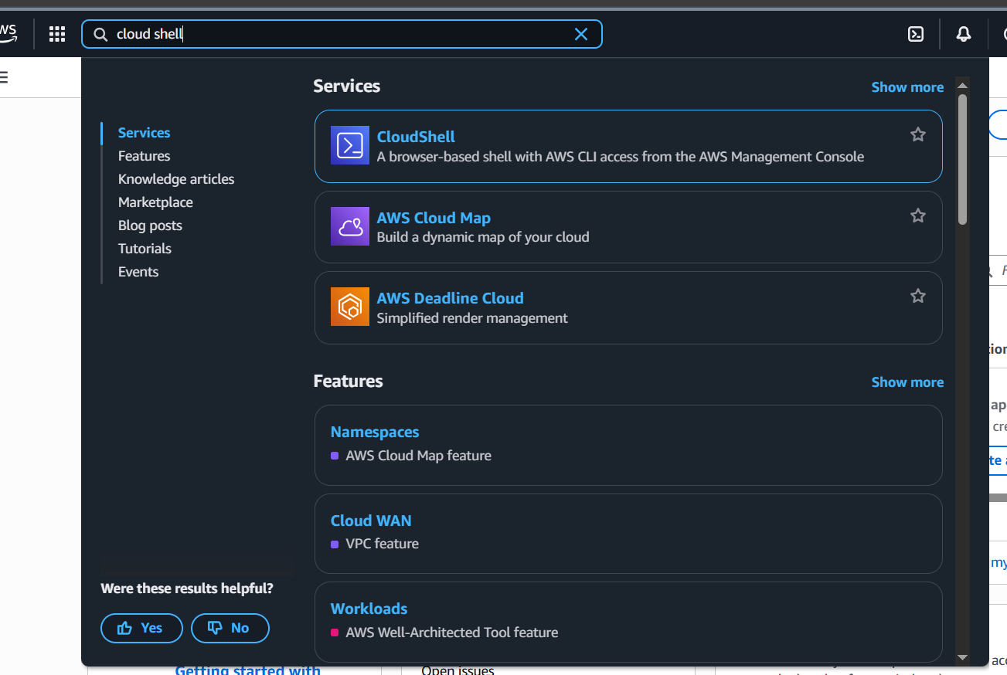
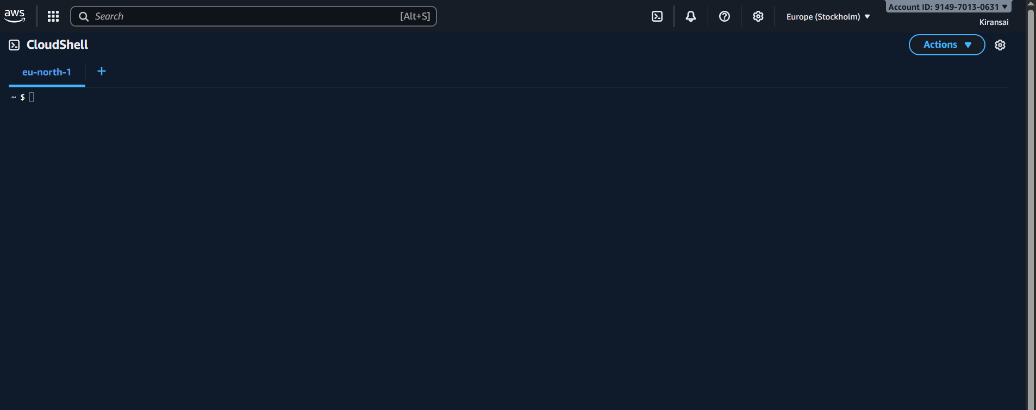

Connect Using Git Bash
Git Bash is a popular terminal for Windows that supports SSH, making it easy to connect to Linux servers like AWS EC2.

Git Bash installed
Download: https://git-scm.com

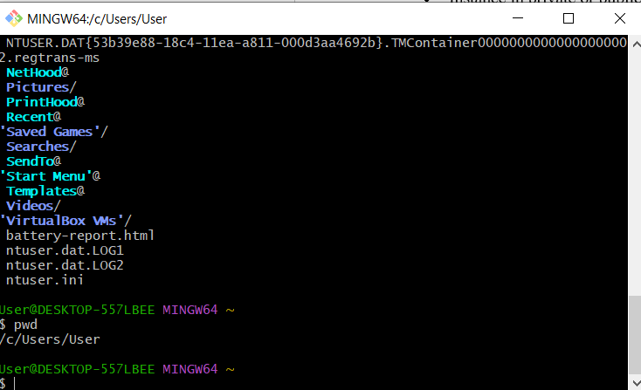

Here are the main types of shells in Linux, explained in very simple language:

🐚 1. Bourne Shell (sh)
- One of the oldest shells.
- Simple and fast.
- Basis for many modern shells.

🐚 2. Bash (Bourne Again Shell)
- Most popular and default shell in many Linux systems (Ubuntu, CentOS, etc.)
- Powerful and user-friendly.
- Supports history, aliases, scripting, autocomplete.

🐚 3. Z Shell (zsh)
- More advanced than bash.
- Very customizable.
- Used in macOS by default.

🐚 4. C Shell (csh)
- Looks like C programming language.
- Not very common today.

🐚 5. tcsh
- Enhanced version of C shell.
- Adds auto-completion, command history.

🐚 6. Korn Shell (ksh)
- Faster and powerful scripting.
- Used in old UNIX systems.

🐚 7. Fish Shell (fish)
(Friendly Interactive Shell)
- Very user-friendly.
- Syntax highlighting, suggestions built-in.

🐚 8. Dash (dash)
- Very light and fast.
- Used by Ubuntu as default for /bin/sh.

